**Económica:**

Esta propuesta se basa en servidores Instalados sobre Windows Server 2012 R2 y sobre Fedora 20, reduciendo asi costos.

|  |  |
| --- | --- |
| **SERVIDORES** |  |
| **INSTALACION** | **SUB-TOTAL** |
| Servidor de correo | Q1,000.00 |
| Servidor FTP | Q500.00 |
| Servidor Samba | Q500.00 |
| Servidor DNS | Q1,200.00 |
| Servidor Base de Datos | Q2,000.00 |
| Servidor Proxy | Q1,300.00 |
| Firewall | Q2,000.00 |
| **TOTAL** | **Q8,500.00** |

|  |  |  |  |
| --- | --- | --- | --- |
| **EQUIPO** |  |  |  |
| **CANTIDAD** | **EQUIPO** | **POR UNIDAD** | **SUB-TOTAL** |
| 2 | Computadoras | Q3,015.00 | Q6,030.00 |
| 1 | Multifuncionales | Q790.00 | Q790.00 |
| 2 | Impresoras | Q255.00 | Q510.00 |
| 3 | UPS | Q299.00 | Q897.00 |
| 2 | Servidores | Q5767.00 | Q11,534.00 |
| **TOTAL** |  |  | **Q19,761** |

|  |  |  |  |
| --- | --- | --- | --- |
| **UTILERIA** |  |  |  |
| **Servicio De TURBONETT** | **CANTIDAD** | **PRECIO UNIDAD** | **SUB-TOTAL** |
| Velocidad: 10Mbps | 1 | Q615.00 | Q615.00 |
| Router 8p. | 2 | Q510.00 | Q1,020.00 |
| Cable UTP Cat. 6 | 200mts | Q3.50 | Q700.00 |
| Licencia Windows server 2012 | 1 | Q6,000.00 | Q6,000.00 |
| Licencia Windows 7 home | 2 | Q800.00 | Q1,600.00 |
| Punto de acceso Inalámbrico | 2 | Q840.00 | Q1,680.00 |
| **TOTAL** |  |  | **Q11,615.00** |

***Módulos: Q 25,000.00.***

Software a la medida (Escalabilidad)

***Descripción:***

* Registro
* Administración (personal)
* Contable.

***Totales:***

|  |  |
| --- | --- |
| **RESULTADOS TOTALES** |  |
| SERVIDORES | Q8,500.00 |
| EQUIPO | Q19,761.00 |
| UTILERIA | Q11,615.00 |
| MODULOS | Q25,000.00 |
| **TOTAL PROPUESTA 2** | **Q64,876.00** |

***Total Propuesta: Q 64,876.00***

***Cotizacion de computadoras***

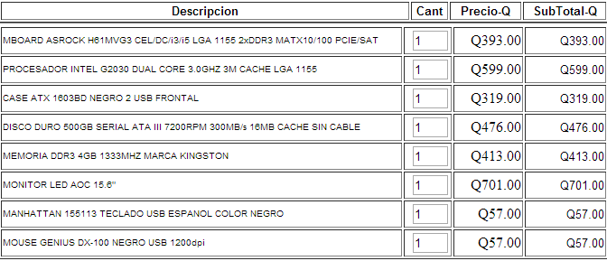



***.***

***Servidores***

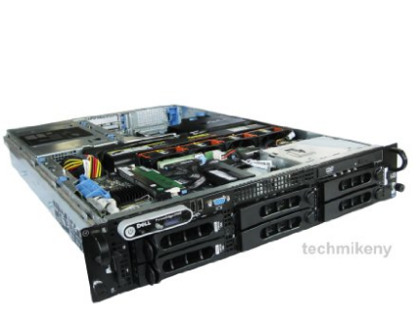

# Dell PowerEdge 2950 Gen III Server

* Dell PowerEdge 2950 2U Rackmount Server (Generation 3)
* 2x 2.33GHz Quad Core Intel Xeons E5345, 16GB Fully Buffered RAM
* Hard drives: 2x 146GB 10K RPM SAS; Supports 6, Includes PERC 5 RAID
* Includes Optical Drive, 2x 750 Watt Power Supplies